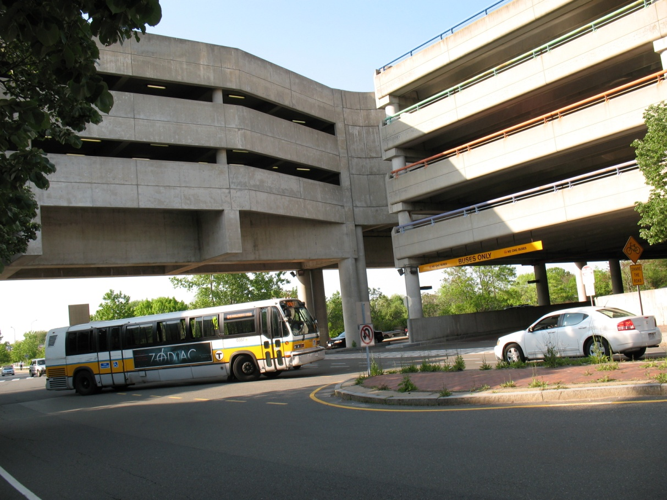NN Logo PMS 307 + K.emf

**May 2011**

**Jason Schrieber & Joshua Weiland**

Transit’s Enemy: Cheap Parking

Transport Chicago

# Transit’s Enemy: Cheap Parking

In dozens of US cities, billions of dollars of transit investment is underutilized because there is a clear financial disincentive to ride the bus or train: if the parking is free, why would anyone with a car ever board transit? Large transit systems with good ridership, such as those in Boston, New York, San Francisco, Washington, and Chicago, mostly benefit from travelers seeking to avoid congestion delays or unable to find cheap or employer-subsidized parking. This paper explores several basic relationships using national comparative data and research with case studies to demonstrate:

* There is a direct relationship between parking cost and ridership;
* The cost of parking is not related to city size and is entirely manipulated by local policies unrelated to market conditions;
* Certain progressive transit agencies have unlocked the power of revealing the true land and market costs of parking to significantly boost ridership; and
* Park and rides should be used sparingly in strategic locations and not wherever space permits.

Case studies include:

* BART’s replacement parking methodology that prioritizes TOD over park and ride;
* Utilization results from the MBTA’s commuter rail parking facilities that counters the accepted approach to meeting Big Dig mitigation requirements;
* The economic success of limiting commuter parking to protect neighborhoods along the Rosslyn-Ballston corridor in Arlington VA;
* The creation of new transit service in Ann Arbor through reduced parking requirements.

The paper’s recommendations may be very instructive for continuing transit-oriented investments in metropolitan Chicago.

In 2007, the villages of Park Forest, Matteson and Olympia Fields, IL conducted a study to investigate transit-oriented development (TOD) around the 211th Street Metra Station (HNTB, 2007). The villages partnered on this study to “establish a welcoming gateway for their communities, create better neighborhood connections to the station, and encourage new mixed-use development within the 211th Street station area” (HNTB, 2007, p. 1-1). As of the writing of the study, the station had two commuter parking lots with a total of 727 spaces (HNTB, 2007, p. 3-8), at 90% utilization (HNTB, 2007, p. 5-2); Metra estimates that 500-600 new parking spaces will be needed by 2030 (HNTB, 2007, p. 3-8). The long-term recommendations include 1,373 commuter parking spaces in two parking garages; this is in addition to non-commuter spaces, and “should be designed to allow for additional levels of parking to be added as demand and funding warrant” (HNTB, 2007, p. 6-5). Repeatedly, the study referenced Metra’s commuter parking guidelines, but does not look at them critically (HNTB, 2007).

Does the 211th Street Station need an extra 500-600 new parking spaces to make a successful TOD? How many spaces should TOD replace? If a station is transitioning from a commuter-oriented station to a mixed-use gateway for their community, should there be any increase in parking spaces, or indeed should there be a decrease?

Through several case studies, this paper argues that a park and ride-oriented station is appropriate for certain locations, however a station serving transit-oriented development is better served by less parking not more – and may be best served with almost no parking. TOD itself has much greater ridership generation than park and ride can provide in any setting where TOD is feasible. Commuter parking spaces tend to reduce the ability of TOD stations to be the attractive gateways that communities like Park Forest, Matteson and Olympia Fields crave.

Several factors that have been observed in the case study data below suggest the following:

* Park and ride ridership profiles involve a peak AM crunch on parking and transit vehicle capacity, requiring extra peak transit capacity. After the morning commute, transit ridership from such stations plummets dramatically, regardless of whether parking capacities are reached or not. Not until the PM peak does ridership pick up again, such that many suburban park and ride stations underperform TOD or village center stations with almost no parking in terms of total daily ridership.
* To provide sufficient capacity for peak park and ride loads, transit providers must have additional equipment and labor available during peak hours. Service to TOD stations, however, does not require such high peak demand as peaks are more spread, requiring less transit equipment. Meanwhile, service to park and ride facilities needs only to be minimal between peaks, leaving providers with underutilized equipment and labor, whereas TOD transit service is better utilized throughout the day, improving efficiencies.
* Walkability, the key to what makes TODs successful, is severely hampered by stations with excessive parking and associated access lanes, ramps, and curb cuts. Many stations labeled as TOD are merely “TAD”, or transit adjacent development which has the look of TOD but the parking supply of stand-alone mixed use development.
* TOD stations with little parking promote more ridership on feeder lines than stations with ample parking because limited automobile access helps force the mode shift desired by planners and transit providers. Stations that never provide parking on new transit lines can evolve into high ridership stations with high ridership feeder service.
* Transit agencies with station area land holdings see much greater return on their investment with TOD versus park and ride, even where parking is priced at market rates. Not only is livable building area more valuable than parking lots or garages, but housing and employment at a station means significantly higher ridership potential and greater net agency revenues.

These points are derived from a review of TOD literature and the following case studies.

South Hayward Station, BART

Bay Area Rapid Transit (BART) was designed to be a hybrid service that supplied frequent rapid rail transit service in the urban centers it connected and regional commuter rail service to displaced centers throughout the Bay Area. Stations in San Francisco and Oakland are closely spaces and served by multiple lines for greater frequency. Stations elsewhere in the Bay Area are further apart and served by only one or two lines at longer headways. The majority of these stations were developed with a standard park and ride design that incorporates large fields of parking surrounding a series of “airport-style” drop-off and feeder bus platforms adjacent to the single station entrance. Even in built-up areas, such as Hayward, this design was used. The South Hayward BART station has currently 1,252 commuter spaces.

On the heels of recent success with the Fruitvale BART TOD, which incorporated a large mixed-use development on top of Fruitvale’s former parking lots in Oakland, BART undertook an effort to evaluate the benefits of expanding TOD on other park and ride lots, with South Hayward being an obvious choice due to the density of the surrounding neighborhoods. BART had a long-standing practice of requiring 1:1 replacement parking. In other words, the developer of a BART surface lot must pay for new parking structures to replace all the spaces lost to the development. This requirement ensures that all existing BART riders can continue to drive and park at the station. At the same time, however, it posed a considerable obstacle for developers, reduced BART revenue and compromised BART’s policy of reducing the share of access by single occupant vehicle. The average cost of building replacement parking is $20k to $30k per space, a sizable increment per unit or per SF of commercial space that must be financed or subsidized. There is also a substantial opportunity cost in devoting land to parking rather than new development with higher revenue streams, especially in the Bay Area. Finally, BART was cognizant that providing commuter parking was an equity issue in that it only served those who drive and park – fewer than half of the total riders at stations like South Hayward.

In recognition of these issues, the BART Board in 2005 adopted a new transit oriented development policy which provides greater flexibility in determining optimum replacement parking levels. A detailed analysis of the ridership and revenue impacts of different levels of parking provision was conducted using a new methodology developed by BART and Professor Richard Willson of the University of California – Los Angeles. The results show that the less replacement parking that is provided, the greater the revenue benefits to BART, and in most cases the greater the ridership as well (Figures 1 and 2). Even though some existing riders are lost as parking is reduced from the current supply, this is far outweighed by ridership generated by the new development that is made possible. Moreover, most development options generate enough revenue to pay for the cost of replacement parking, a new bus intermodal facility, and place-making investments in the station area.

Note that these results stand in contrast to options where higher levels of replacement parking and lower development densities meant that, although there was a net ridership increase, there was a negative financial impact on BART. Allowing for 75 percent (or greater) BART replacement parking would likely require some form of public funds to advance the project, which is exactly what happened with the successful Fruitvale TOD that was still committed to building replacement parking years later in a slightly remote site, even though the development was a resounding financial and ridership success.

Figure 1: Ridership and Revenue Impacts



Figure 2: Ridership and Revenue Calculations

|  |  |  |  |
| --- | --- | --- | --- |
|  | **Revenue Factors** | **60% BART Replacement Parking** | **75% BART Replacement Parking** |
| A | Net change in ridership | 1,698 | 1,841 |
| B | Ne change in annual fare revenue | $1,357,302 | $1,470,932 |
| C | Net parking revenue | $114,471 | $142,768 |
| D | Land value | $20,999,055 | $19,524,872 |
| E | Cost of replacement parking | $17,596,600 | $22,552,600 |
| F | Annual ground rest after parking costs | $340,246 | ($302,773) |
| G | Reduction in parking operating cost | $60,195 | ($34,964) |
| H | Annualized capital costs for intermodal facility and placemaking elements | $500,000 | $500,000 |
| **I** | **Net annual impact (B+C+F+G-H)** | **$1,372,213** | **$775,964** |

Commuter Rail Parking, MBTA

As part of the Big Dig project in Boston, in which Interstate 93 was placed under the city, the Conservation Law Foundation and the Commonwealth of Massachusetts came to an agreement that was intended to mitigate air pollution due to increased automotive capacity in the downtown. Part of this agreement was the Massachusetts Bay Transit Authority’s (MBTA’s) commitment to create 10,000 new parking spaces at the region’s transit stations.

Data, however, does not support the creation of so much new parking. More specifically, the data suggests that the MBTA, as with other systems, should not simply create parking at all stations, but must be judicious in deciding where parking should be increased and where it should be decreased. One major factor should be the mix of uses, as well as the development and use aspirations of the surrounding community.

The mix of uses, of course, helps drive ridership. An analysis of a 2004 MBTA Commuter Rail Parking Lot Utilization Study overlaid on a 2005 MBTA Train Audit shows that stations that have dense mixed-use districts within walking distance have higher ratios of boardings per parked car, often while maintaining high levels of ridership. This means that systems can build less parking but maintain ridership.

The MBTA operates over 100 commuter rail stations in the metro-Boston area. They can be categorized by setting, into village, park and ride, and downtown stations. Park and ride stations are generally along highways or in remote commuter-oriented settings. Village stations have walkable, mixed use centers, but are not necessarily very developed or dense. Downtowns are city and town centers outside of Boston and Cambridge proper that are walkable, mixed-use and dense. As Figures 3-5 show, park and ride stations maintain an average boarding per parked car of 1.9, while village settings maintain 4.7 boardings per parked car, and downtowns have 6.6 boardings per parked car.

This data suggest that for transit to have sufficient ridership to warrant the investment in service, stops that are intended to be walkable village centers and downtowns do not need additional commuter parking. Indeed, to grow ridership, reducing parking may be a better strategy, especially where infill development can occur. Where conditions do not support density, commuter parking can be constructed, but it should be done so in locations with good regional roadway access where communities do not want to develop walkable village centers or downtowns.

Regardless, MBTA policy continues to adhere to its agreement with the Conservation Law Foundation by working with any community seeking to build new parking near a commuter rail station. Garages that have been built or approved recently are exclusively in downtowns, including Haverhill, Salem, and Beverly, which unfortunately happen to have some of the highest boardings and lowest automobile access rates in the region.

Figure 3: Ratio of Boardings to Parked Cars – Park & Ride Stations



Figure 4: Ratio of Boardings to Parked Cars – Village Center Stations



Figure 5: Ratio of Boardings to Parked Cars – Downtown Stations



Downtown Parking, Ann Arbor

The cost of commuter parking is not simply financial, it consists of a substantial opportunity cost. In Ann Arbor, MI, by forgoing the creation of new parking, funds were dedicated to new buses.

The City of Ann Arbor, through its Downtown Development Authority (DDA) manages nearly all public parking in the city’s downtown — including on- and off-street parking spaces — with the goal of balancing parking accommodation with demand management to produce the maximum benefit to the community. The provision of a comprehensive, managed parking supply, combined with an absence of minimum parking requirements, relieves developers of pressures to provide on-site parking at downtown projects. This promotes the compact, dense, mixed-use development patterns that make downtown Ann Arbor a high-demand residential, employment, and recreational destination — and an uncommon economic success within a long-struggling region.

Over the years, the DDA has worked to address the concerns on all sides of the parking supply and demand debate by refurbishing parking assets and reaching out to businesses to monitor their needs, while at the same time using parking funds to invest in innovative demand-management programs, including:

* A Universal Transit Pass program where participating employers pay $5 for annual, unlimited-ride bus passes for their employees;
* The getDowntown program which promotes a multi-modal focus on commuting to Downtown jobs[1].
* Downtown Zipcar sponsorship in collaboration with the University of Michigan Zipcar program

The DDA has also adopted the core philosophy that parking should “pay for itself”, without need for tax subsidies. The basic reasoning behind this philosophy is that the users of the parking system can and should pay for the system, which means that others who oppose parking on principle or who don’t use the parking system are not contributing to its operation and maintenance. The DDA’s many non-parking investments are based on the basic economic principle that parking is but one means of providing downtown access and that building parking structures (at roughly $30,000 per space and up) often buys less downtown access than other transportation investment options, and the diversity of uses in downtown require a diversity of transportation solutions.

This comprehensive approach to parking and transportation is at the heart of the City’s current parking management practices — practices that conform closely to many core, parking-management best practices, including:

* No Minimum Requirements: There are no parking requirements for as-of-right development within Downtown;
* Shared Parking/ Park Once: Nearly all Downtown trip generators rely upon a consolidated inventory of shared public parking; and
* Public Management: All public off-street parking facilities are owned and managed by the DDA.
* Choice: The DDA offers several different types of monthly parking permits and different hourly parking rates at different times of day or location to provide patrons with opportunities to select the option that best meets their needs based on desire for more/less convenience, price, etc.

The DDA has invested in parking. For example, The DDA is currently building a new, 670-space underground parking structure as part of a larger project intended to encourage redevelopment of a center city core area. The project includes three new water mains, extensive electrical infrastructure, added structural support for a future building at grade, a new midblock street, a new alley, and pedestrian improvements. In keeping with its long-held separation of funds, the new parking structure portion of this project will be fully paid for with parking revenues generated by the users of the public parking system, with no use of tax dollars.

In 2000, the DDA began funding Transportation Demand Management (TDM) investments as a means to reduce demand for parking expansions and to meet the needs of downtown users who choose not to or can’t afford to park. It has found that addressing parking demand is more often than not much cheaper than building and maintaining new supplies. Two of the longest-standing and most successful investments have been a Universal Transit Pass program (the Go!Pass) and a Commuter Benefits information clearinghouse and marketing service (getDowntown).

**Go!Pass:** The DDA, the Ann Arbor Transit Authority (AATA), and the getDowntown program launched the Go!Pass, universal transit pass, offering unlimited rides for a small annual employer-paid fee[2], in the fall of 1999. As of 2009, there were approximately 6,000 Go!Passes in use. The DDA subsidizes 90% of the cost for the go!pass.

**getDowntown:** The getDowntown program was launched by the Ann Arbor Area Chamber of Commerce, the DDA, the City, and AATA in 1999 to reduce the number of downtown commuters driving to work and to create more transportation choices for downtown commuters through promoting existing transportation options and advocating for new ones. getDowntown strives to accomplish this mission by promoting existing choices, providing research on the benefits of sustainable transportation, organizing events, interacting with downtown employers and employees, and interfacing with numerous downtown stakeholders. The program provides a wide range of services for downtown employers, employees, and property managers. It advises downtown property owners on ways to reduce the need for tenant parking and provides information and assistance to downtown businesses and employees on commuting options, such as biking, riding the bus, walking, and ridesharing. The DDA provides significant operational funding for the program, in addition to grants for promotional events and studies.

Two more recent examples of significant investments are financial support for new commuter-express bus service to downtown and expansion of bicycle parking facilities, including on-street racks.

**A2 Express Service:** Beginning in 2007, DDA funding helped the AATA inaugurate a new type of bus service for downtown and the University of Michigan Central Campus from communities outside Ann Arbor: a commuter, express service provided via first-rate. “over-the-road” coach buses. This service tapped directly into sentiments expressed by commuters who would prefer to use transit but found existing service travel times too much of a barrier. Several commuters made clear that, for a monthly cost comparable to monthly permit rates, and travel times not too much higher than driving, they would gladly opt for bus service that would allow them to read, knit, or sleep on the way. Beginning with one route, and expanding to two routes in 2009, the A2 Express Service began to test this demand, bringing competitive bus service to the suburban market. Unlimited ride passes cost $125 ($5 cheaper than a standard garage permit). With a Go!Pass card, the fare is halved to $62.50, a subsidy that is provided by the DDA.

**Bicycle Parking:** In summer 2009, the DDA installed three new bicycle parking options to add to those already in place. Taking a cue from Seattle and other communities, several on-street bicycle-parking racks were placed in metered spaces throughout the downtown to further enhance the popularity of bicycle commuting in downtown and to relieve pressure on sidewalks swamped with full bike racks. The racks accommodate up to 14 bicycles in the space that would otherwise accommodate a single car. They will remain in place during warm weather months, when bicycling is more popular, and removed when cold weather decreases cycle-parking demand to allow for snow plowing and other maintenance. In another project copied from other communities, the DDA installed new bike hoops on the posts that serve as parking space numbers for the e-park system noted above.

Ann Arbor’s downtown demonstrates how increased transit ridership and new transit service can be driven without a reliance on commuter parking supplies. The DDA realized that providing transit, biking, and walking facilities was far more cost-effective per commuter than building more parking garages.

Transit-Oriented Development, Arlington VA

Arlington County provides one of the most successful examples in the United States of development tied to transit. Nearly 18,000 residential units, almost 14 million square feet of offices, 1.5 million square feet of retail, and 1,218 hotel rooms have been built since the start of the 1980s in the area served by the Rosslyn, Court House, Clarendon, Virginia Square, and Ballston stations of Washington DC’s MetroRail system.

This degree of success would not have been possible without the protective planning decisions taken in the 1960s regarding Metrorail. At the time, the Rosslyn-Ballston corridor was an aging, low-density commercial stretch that was facing decline and losing population and retail business. In a move to support this corridor and spur future development, County leaders insisted that Metro be built underground, rather than in freeway medians. Meanwhile, residents demanded that their abutting single-family neighborhoods be protected from new development.

The County was only able to channel new development in the narrow strip of land along the corridor, severely limiting the ability to build parking as well as new development. The solution is one of the best TOD success stories in the U.S. Over and above the stations, the County promoted high density development, with floor area ratios of 4.0-10.0 and 15-20 stories of development. By design, densities and height then rapidly taper down, eventually ending with townhouses closest to the existing single-family residential areas.

Key to sustaining this development was minimizing the cost and space dedicated to parking supply. Therefore, nearly all commercial parking is in shared garages with no provision for commuters. All on- and off-street parking is priced cheaply for short stays but escalates significantly to discourage commuter parking.

Transit ridership has increased rapidly as a result (Figure 6). Most importantly, the mixed-use nature of Arlington’s transit-oriented development has promoted balanced ridership over the course of the day, rather than the sharp AM and PM peaking experienced at more park-and-ride oriented MetroRail stations. Therefore, MetroRail ridership on the corridor is strong during off-peak hours as well as peak due to many midday trips occurring by transit rather than car. The Ballston station is a good example of a mixed-use station area with balanced ridership. Nearly two-thirds of riders at Ballston station walk to the Metro.

The effect of such policies can be seen when comparing to Fairfax County, which surrounds Arlington:

Figure 6: Ridership Surveys on Virginia MetroRail Stations

Arlington has been able to grow rapidly without major expansions in the highway network. It has also achieved economic prosperity, with the lowest property tax rate among the major cities and towns in Northern Virginia and a AAA bond rating. The Metrorail corridors provide 50% of the County’s tax base, on only 7% of the land. The County also enjoys far lower vacancy rates and higher lease and sale prices, compared to other locations in the region.

Another success is Market Common, a mixed-use TOD near Clarendon Station. Here, the parking requirement is 25% less than code, even though the station is a short walk away. Market Common is making use of several innovative techniques, including shared parking, with no assigned spaces for residents, shoppers or commuters. Residential parking is unbundled, in which parking cost is not included with housing cost, but is a separate, optional purchase. Residents pay $25 per month for parking, while others pay daily. With parking at 25% below code, the property management says that 40% of spaces are not being used.

1. <http://getdowntown.org/>
2. In 2009, the fee was $5 per year, although, to participate, employers must purchase a pass for all full-time employees.