Using GIS to Combine Spatial Data with Non-spatial data to Identify Trip Patterns
Hong Yang
Hong.Yang@pacebus.com
Pace Suburban Bus, 55 W Algonquin Rd, Arlington Heights, IL 60005
Abstract
Identifying a trip is as either a single trip or a transfer trip is used for transportation planning to recognize trip patterns, design routes, and streamline scheduling. The agency’s Cubic transaction system, a fare system based on passengers, captures the passenger’s boarding time, route and run information, and fare media serial number. However, spatial information to locate where the passenger boards is not captured by this system. The agency’s Intelligent Bus System (IBS) collects bus time points with spatial locations (the x and y coordinates). By linking together information in the two systems, GIS enables transportation planners to identify each passenger’s boarding location and, where applicable, transfer location. This study demonstrates an ArcGIS desktop application to identify trip patterns for transportation planning purpose by combining the non-spatial Cubic transaction data with the spatial IBS data.
- Introduction
Discovering whether a customer’s trip is a single trip or a transfer trip is useful for transportation planning to recognize trip patterns, design routes, and streamline scheduling.
Pace, the suburban bus service agency in the Chicago metropolitan area, provides regular bus routes and specialized services throughout a six county region in Northeastern Illinois. Map 1 shows Pace’s service area and all the fix routes in the service area.
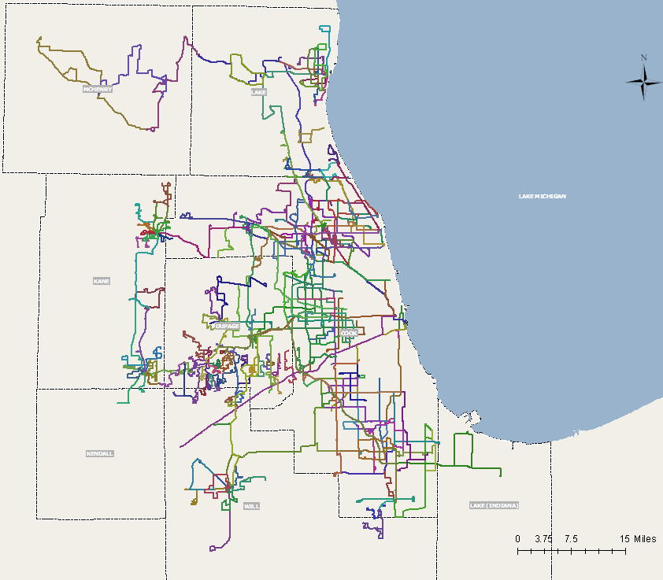
Map 1: Pace Service Area and Fix Routes
Pace has two systems collecting fix-route-related trip information, Cubic transaction system and Intelligent Bus System (IBS). Pace’s Cubic transaction system is a fare collection and recording system. In this system, passengers using fare media are uniquely identified when boarding a bus using their fare pass. The current route name, fare media type, and bus number are time stamped when the card is used. The data also includes information on the previous bus the same passenger took. However, there is no spatial information to locate where the passenger boards. Pace’s IBS currently tracks and collects buses’ spatial locations (the x and y coordinates) with time points. GIS enables linking data from the two systems together, and thus allows transportation planners to differentiate transfer trips from single trips, determine each passenger’s boarding location and transfer location of a transfer trip, and discover passengers’ trip patterns.
This paper demonstrates a customized GIS desktop application that combines the non-spatial Cubic transaction data with the spatial IBS data to identify passengers’ transfer locations. The result of this application is a point feature class which can be further analyzed for trip pattern identification.
- GIS Application Identifying Trip Transfer Locations
Although Cubic transaction system and IBS are designed for different purposes, there is common data collected by both systems, including route name, bus number and timestamp. This makes possible link the data in the two systems together to study passengers’ trip behaviors and explore the existence of any spatial trip patterns. However, both systems contain tremendous amount of data. It is almost unmanageable for transportation planners to inspect the data in the two systems manually for trip pattern analysis.
A customized ArcGIS desktop application was built using ArcObjects and .NET programming languages to extract information from the two systems. This application is able to distinguish transfer trips from single trips, locate passengers’ boarding and transfer locations, and display the transfer locations on the map for visualization.
  - Application Assumptions
This application was built based on the following assumptions:
- The time clocks of the Cubic transaction system synchronize with the time clocks of IBS.
- The GPS units installed in the buses function correctly all the time.
- If the same fare card is used more than once within 3 minute, it is not due to a transfer.
  - Application Interface Design
This application was friendly designed to allow transportation planners to select and change the following parameters to create outputs for analysis purpose: date range, transfer time window (i.e. how many minutes later a second trip taken from the first one is considered a transfer trip), and the fare media type the passenger used (See Figure 1).
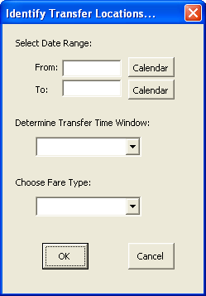
Figure 1: Identify Trip Transfer Location Application Interface
  - Application Logic and Workflow
The illustration below shows the logic and workflow of this application.
Records of passengers with multiple entries
Cubic Transaction
System
Intelligent Bus System (IBS)
Are there multiple records of the same passenger in the selected time window?
Is the last route of a passenger’s transaction the same as the current route of his/her previous transaction?
Yes
Yes
Passengers identified as making transfers
Route Name, bus Number and timestamp
What is the logged bus location just before the timestamp?
Logged bus location before the Card used identified
Passengers identified as making transfers with transfer locations
Figure 2: Logic and Workflow of Trip Transfer Location Identification
This application first processed the records in the Cubic Transaction System to discover the passengers who take more than one trip in the selected analysis period. For those passengers that have multiple entries in the system, the last route value of the current record was compared with the current route value of their previous record. If there is a match, this passenger is considered to take a transfer. Then the passenger’s current route number, bus number, and timestamp were used to search the logged bus locations in IBS. The bus location just before the passenger’s timestamp was identified as the passenger’s estimate transfer location. Although it is not the exact location where transfer occurs, it is close enough for analysis purpose.
- Application Results Analysis
The output of this application is a point feature class showing locations where transfers occur. Each output feature contains more data than the spatial transfer location. Those data include both passengers’ boarding and transfer information. Please refer to Figure 3 for details where c represents current and l represents last.
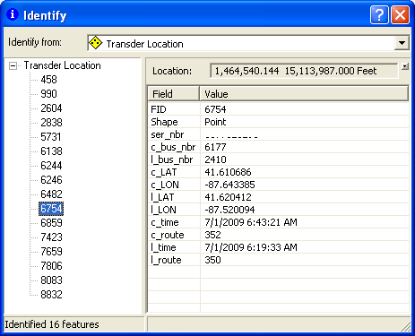
Figure 3: Attributes of Transfer Location Feature
Map 2 shows a sample result of the application, i.e. the transfer locations that take place in a 20-minute transfer window in a selected date. As shown, there are several locations with cluster transfers happened in that day.
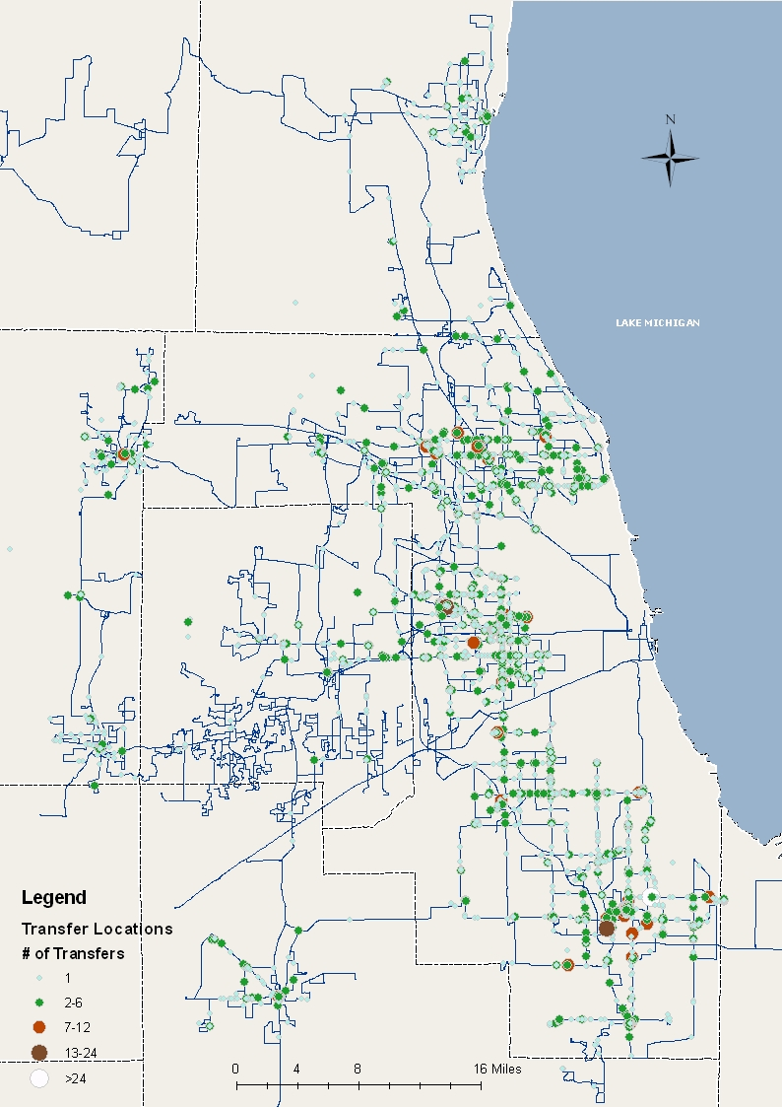
Map 2: Transfer Locations in a Selected Date
Map 3 shows one of the cluster locations in the sample result.
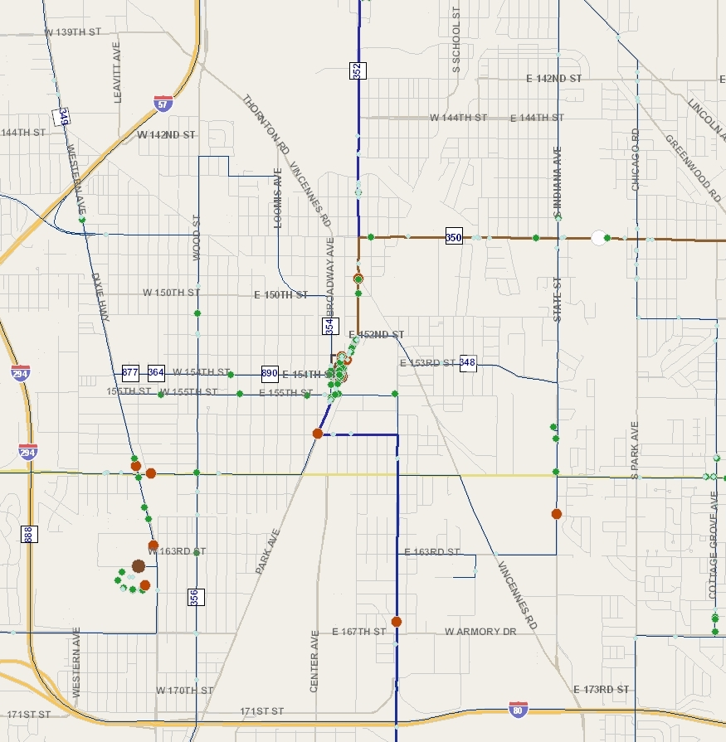
Map 3: One of the Cluster Transfer Locations
Further study on the cluster locations can help identify on which routes majority of the transfers take place. For example, most of the cluster transfers shown in map 3 happened between Route 350 and Route 352 (see Map 4).

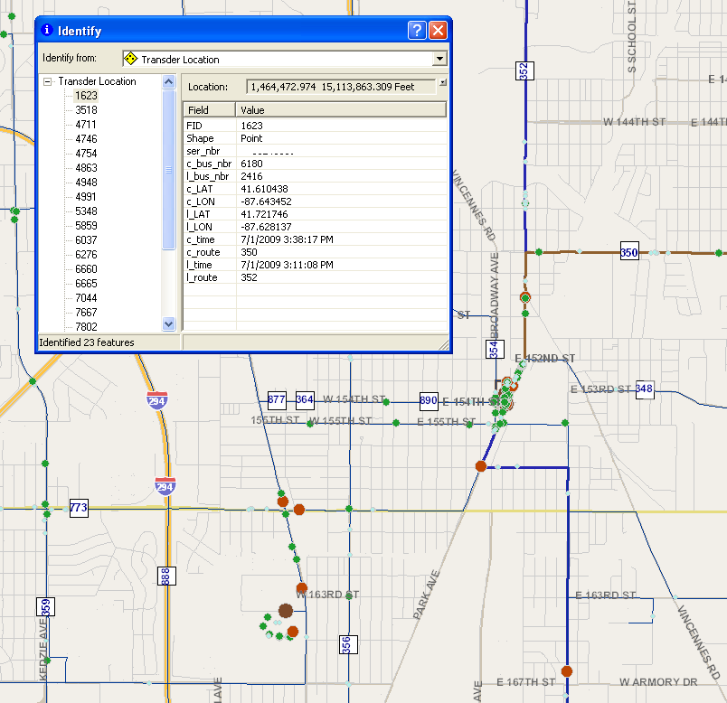
Map 4: Routes of Transfers
Combined with the transfer locations, passengers’ boarding locations can also be mapped for trip patterns analysis and identification.
- Conclusion
This paper demonstrates a customized GIS desktop application that combines the non-spatial Cubic transaction data with the spatial IBS data to detect passengers’ transfer locations. As illustrated, this application can facilitate transportation planners to identify and analyze transfer trips, detect the existence of any trip patterns, and make intelligent decisions.

