Suburban Cook County Travel Market Analysis
Summary of Findings

Prepared by:

Hersh Singh, Strategic Planner
Janine Farzin, Principal Analyst
Peter Fahrenwald, Manager of Regional Planning

Regional Transportation Authority (RTA)
175 W. Jackson Blvd, Suite 1650
Chicago, IL 60604

Introduction
The Regional Transportation Authority (RTA) is responsible for oversight over the Chicago Transit Authority (CTA), Metra, and Pace. These three agencies provide transportation services that serve the six-County Northeastern Illinois region: Cook, DuPage, Kane, Lake, McHenry, and Will Counties.

Findings from the 2010 RTA Travel Market Analysis and the 2007-2008 Chicago Metropolitan Agency for Planning (CMAP) Household Travel Tracker Survey have been utilized in order to understand regional travel demand and travel markets in an attempt to better identify the region’s major travel patterns. The RTA Market Analysis concluded with a recommendation to increase utilization of the existing transit system for non-traditional markets. In this analysis, the goal is to investigate suburban Cook County’s high transit availability yet low transit utilization. Suburban Cook County is the study region and there are five sub-regions in the analysis (see Appendix A Reference Map). East DuPage County was included as part of the study region due to the high level of connecting transit services with portions of suburban Cook County. This initial, high-level analysis will help in determining which area may best be suited for additional planning resources in the future.

For the analysis, RTA district boundaries were utilized (as defined in the RTA Market Analysis) to divide the study region into five sub-regions: North Suburban Cook, Northwest Suburban Cook, West Suburban Cook, South Suburban Cook, and East DuPage County (see Appendix A Reference Map). Each sub-region is comprised of three RTA districts.

This executive summary aims to summarize and highlight findings from the individual analyses conducted for each of the sub-regions.

Table of Contents

- Background

- Household Demographics

- Travel Behavior and Transit Trip Characteristics

- Findings & Conclusions from Home Based Work (HBW) Regional & District Trip Interchanges

5. Recommendations for Further Analysis

- Background
Findings from the RTA Travel Market Analysis Study showed that suburban Cook County has high availability of transit service yet low utilization. Suburban Cook County (all portions of Cook County excluding the city of Chicago) produces a similar amount of daily trips for all trip purposes as the city of Chicago, at 8,478,365 and 8,373,659 trips respectively. However, Chicago’s transit share is nearly seven times that of suburban Cook County, at 14.1 percent and 2.6 percent respectively. To put the numbers in perspective, Suburban Cook County’s transit share is closest to that of Lake County, at 1.9 percent. However, suburban Cook County has a much higher level of transit availability. In addition to route miles, suburban Cook County has higher levels of transit service in terms of frequency and span of service.

- Household Demographics
This section outlines household demographic characteristics for each sub-region with a focus on variables that influence transit use. Findings from the RTA Travel Market Analysis revealed the following about the region:

  - Transit use increases with household size
  - Transit use falls with surplus of vehicles – (household vehicles – household workers)
  - Transit use increases with the number of household members working in the CBD.

Table 1 highlights some household demographic characteristics for each of the sub-regions in the analysis. High averages are highlighted in yellow, while low averages are highlighted in gray for the sub-regions. As seen in Table 1, the sub-regions are fairly similar when examining these household demographics. The one exception is Northwest Suburban Cook County which has a higher average number of vehicles, household workers and has the fewest jobs oriented to the CBD. In each of the sub-regions, the average number of household vehicles exceeds the average number of household workers which indicates that the majority of households in Suburban Cook have as many vehicles as workers or more. East DuPage County has the highest average number of household members with jobs in Chicago’s central business district (district 24).

Table 1 Household demographics by sub-region
Sub-regions | Weighted Sample Population | Mean HH Size | Mean HH Vehicles | Mean Number of HH Workers | Mean Number of Jobs in CBD
North Sub Cook | 186,950 | 2.49 | 1.66 | 1.41 | 0.13
Northwest Sub Cook | 276,079 | 2.52 | 1.97 | 1.56 | 0.08
West Sub Cook | 270,843 | 2.54 | 1.7 | 1.43 | 0.12
East DuPage | 115,454 | 2.5 | 1.81 | 1.46 | 0.14
South Sub Cook | 162,767 | 2.38 | 1.73 | 1.42 | 0.09
Total - Study Region | 1,012,092 | 2.5 | 1.78 | 1.46 | 0.11
Total - Six County Region | 3,025,072 | 2.43 | 1.55 | 1.37 | 0.11

The CMAP household travel tracker survey also attempted to quantify “transit households” in the region. A transit household is defined as a household where at least one member reported using transit at least once a week. This variable aims to help quantify propensity to utilize transit in the region by identifying households that are familiar with transit. In the study region, North Suburban Cook County has the highest percentage of transit households, while Northwest Suburban Cook County has the lowest.

Figure 1 Transit households by sub-region
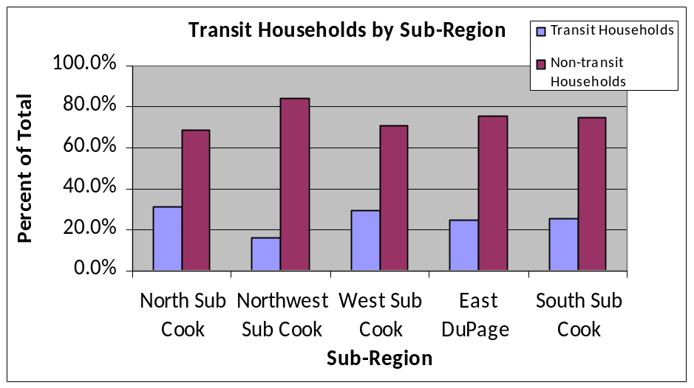

Table 2 Transit households by sub-region
Transit Households by Sub-Region
 |  | Transit Household |  | Total
 |  | Yes | No | Total
North Sub Cook | % | 31.7% | 68.3% | 100.0%
Northwest Sub Cook | % | 15.9% | 84.1% | 100.0%
West Sub Cook | % | 29.1% | 70.9% | 100.0%
East DuPage Cook | % | 24.7% | 75.3% | 100.0%
South Sub Cook | % | 25.1% | 74.9% | 100.0%

Findings from the RTA Travel Market Analysis also show that households of all income ranges use transit. Interestingly, transit households in the six-county region have a U-shaped distribution when plotted against annual household income (see Figure 2): transit use tends to increase among low income households, reduces for middle income households, and then increases again for high income households. In contrast, when examining households in the study region (Figure 2), the share of lower income households drops as it relates to regular transit use. In addition, a larger share of high income households in the study region appear to be transit households when compared to the entire six county region.

Figure 2 Regular household transit use and household income by Region

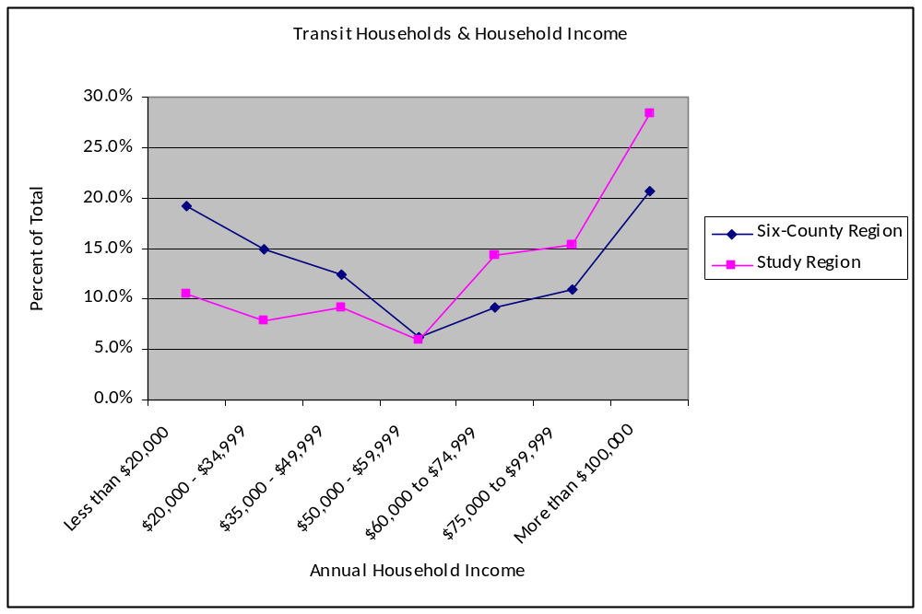

Table 3 displays annual household income for each sub-region. The majority of households in each of the sub-regions reported having annual incomes in excess of $100,000, except for South Suburban Cook County where the majority of households reported having an annual income of $20,000 to $34,999.

Table 3 Household income by sub-region
Household Income
 |  | Less than $20,000 | $20,000 - $34,999 | $35,000 - $49,999 | $50,000 - $59,999 | $60,000 - $74,999 | $75,000 -$99,999 | More than $100,000 | Refused | Total
North Sub Cook | % | 3.4% | 10.9% | 6.8% | 10.2% | 15.2% | 13.4% | 28.3% | 11.8% | 100.0%
Northwest Sub Cook | % | 2.9% | 9.5% | 14.1% | 9.3% | 14.6% | 13.5% | 29.7% | 6.3% | 100.0%
West Sub Cook | % | 13.3% | 13.4% | 11.8% | 6.8% | 14.4% | 13.3% | 19.2% | 7.9% | 100.0%
East DuPage | % | 7.7% | 13.3% | 9.0% | 8.5% | 11.7% | 14.4% | 26.9% | 8.5% | 100.0%
South Sub Cook | % | 13.5% | 19.3% | 15.2% | 6.3% | 7.8% | 17.9% | 16.3% | 3.7% | 100.0%
Study Region | % | 8.0% | 12.8% | 11.7% | 8.2% | 13.2% | 14.2% | 24.2% | 7.6% | 100.0%

The RTA Travel Market Analysis also revealed a statistically significant correlation between transit use and duration at current residence. New mover households (defined as those households that moved into the region from outside the region within the past two years) show a higher propensity to use transit when compared to more established households. Figure 3 and display relocation status and transit use for the six county region.

Figure 3 Relocation status and transit use in the six-county region
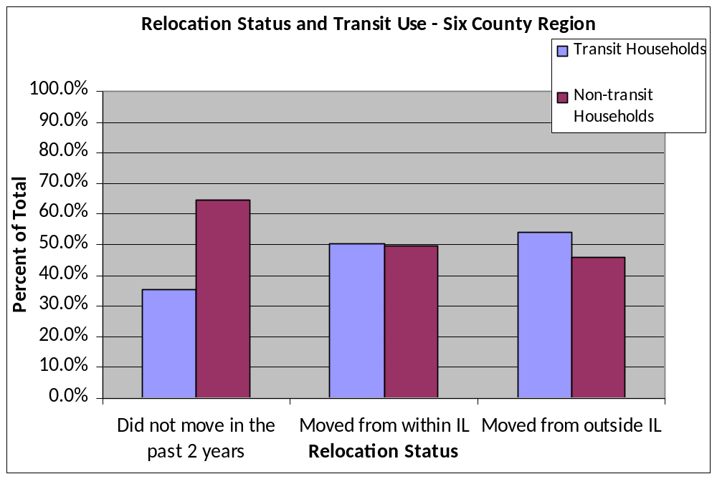

Table 4 Relocation status and transit use by six-county region
Relocation Status and Transit Use - Six County Region
 |  | Use Transit |  | Total
 |  | Transit Household | Non-Transit Household | Total
Did not move in the past 2 years | % | 35.2% | 64.8% | 100.0%
Moved from within IL | % | 50.6% | 49.4% | 100.0%
Moved from outside IL | % | 54.1% | 45.9% | 100.0%

Figure 4 and Table 5 display the same information for the study region. The positive correlation between the two variables for the six-county region does not appear to hold true when solely examining the study region. Instead, transit use for households in the study region remains fairly consistent regardless of residential tenure.

Figure 4 Relocation status and transit use in the study region
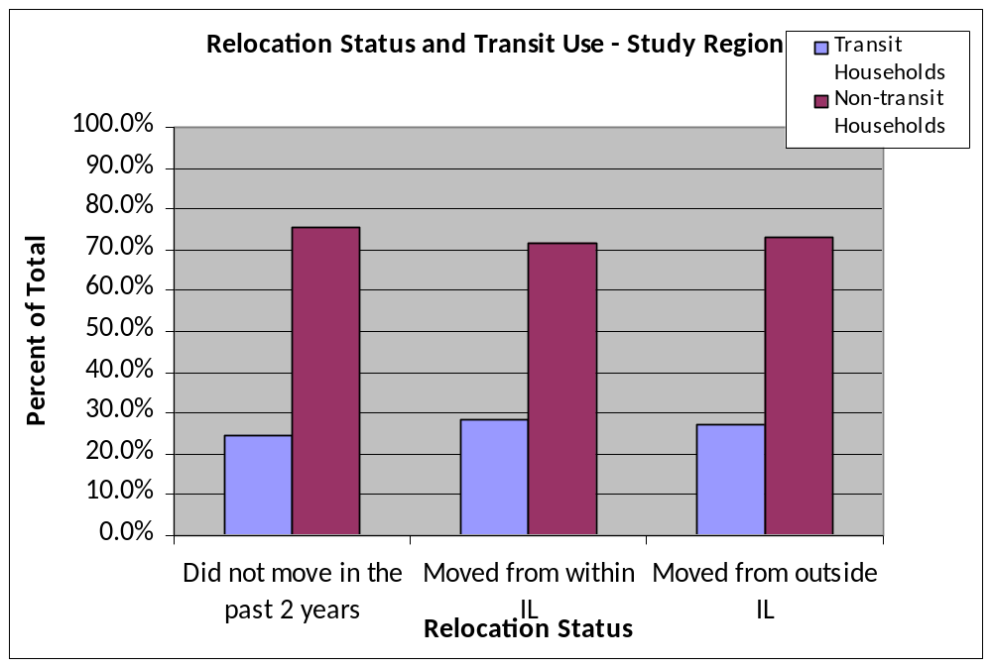

Table 5 Relocation status and transit use by study region
Relocation Status and Transit Use - Study Region
 |  | Use Transit |  | Total
 |  | Yes | No | Total
Did not move in the past 2 years | % | 24.4% | 75.6% | 100.0%
Moved from within IL | % | 28.2% | 71.8% | 100.0%
Moved from outside IL | % | 27.2% | 72.8% | 100.0%

As seen above, the positive correlation between new movers and transit is much less pronounced for
residents in the study region. A Chi-Square test of significance revealed that there is a strong relationship between relocation status and transit use in the City of Chicago. Therefore, much of the difference can be attributed to the fact that the regional statistics include the City of Chicago.

Travel Behavior and Transit Trip Characteristics
In the following sections home-based school (HBSch) trips have been combined into the home-based work (HBW) category, due to their similarities in being routine and occurring predominately during peak commuter periods. Together, these trips are viewed as “low hanging fruit” and provide a strategic starting point in the goal of increasing transit utilization.

Mode Share
Table 6 displays the transit mode share for all trip purposes and HBW trips that originate in each of the sub-regions. As is typical, transit mode share is higher for HBW trips than for all other purposes.

Table 6 Transit share by trip purpose
 |  | All Trip Purposes | HBW/HBSch
North Sub Cook | Count | 59,981 | 40,282
North Sub Cook | % | 2.8% | 7.1%
NW Sub Cook | Count | 17,234 | 14,044
NW Sub Cook | % | 0.7% | 1.8%
West Sub Cook | Count | 62,086 | 37,662
West Sub Cook | % | 2.5% | 5.8%
East DuPage | Count | 18,448 | 16,125
East DuPage | % | 1.4% | 4.6%
South Sub Cook | Count | 33,130 | 20,865
South Sub Cook | % | 2.4% | 5.4%
Total - Study Region | Count | 190,879 | 128,978
Total - Study Region | % | 1.9% | 4.7%
Total - Six County Region | Count | 1,617,307 | 900,726
Total - Six County Region | % | 6.1% | 11.6%

Table 7 and Table 8 go into further detail and provide a break down of transit trips by mode and trip purpose. Regardless of trip purpose, Metra is the dominant transit mode in the study region. Metra’s transit share is highest for Northwest Suburban Cook County and lowest for North Suburban Cook County. However, CTA (bus and train combined) is the dominant service provider in the North and the West sub-regions.

Table 7 Transit trips by transit mode for all trip purposes by sub-region
 |  | Travel Mode - All Trip Purposes
 |  | CTA Bus | CTA Train | Pace Bus | Metra Train | More than one transit provider | Transit | Total
North Sub Cook | Count | 15,407 | 16,265 | 4,831 | 17,259 | 6,219 | 59,981 | 2,134,058
North Sub Cook | % | 25.7% | 27.1% | 8.1% | 28.8% | 10.4% | 100.0% | -
NW Sub Cook | Count | 1,320 | 88 | 1,739 | 12,301 | 1,786 | 17,234 | 2,543,454
NW Sub Cook | % | 7.7% | 0.5% | 10.1% | 71.4% | 10.4% | 100.0% | -
West Sub Cook | Count | 8,906 | 13,962 | 14,287 | 16,575 | 8,356 | 62,086 | 2,461,388
West Sub Cook | % | 14.3% | 22.5% | 23.0% | 26.7% | 13.5% | 100.0% | -
East DuPage | Count | 26 | 1,262 | 1,203 | 9,967 | 5,990 | 18,448 | 1,332,498
East DuPage | % | 0.1% | 6.8% | 6.5% | 54.0% | 32.5% | 100.0% | -
South Sub Cook | Count | 176 | 216 | 12,029 | 13,932 | 6,777 | 33,130 | 1,372,325
South Sub Cook | % | 0.5% | 0.7% | 36.3% | 42.1% | 20.5% | 100.0% | -
Study Region | Count | 25,835 | 31,793 | 34,089 | 70,034 | 29,128 | 190,879 | 9,843,723
Study Region | % | 13.5% | 16.7% | 17.9% | 36.7% | 15.3% | 100.0% | -

Table 8 Transit trips by transit mode for HBW/HBSch trips by sub-region
 |  | Travel Mode – HBW/HBSch
 |  | CTA Bus | CTA Train | Pace Bus | Metra Train | More than one transit provider | Transit | Total
North Sub Cook | Count | 10,376 | 8,636 | 3,830 | 13,677 | 3,763 | 40,282 | 569,623
North Sub Cook | % | 25.8% | 21.4% | 9.5% | 34.0% | 9.3% | 100.0% | -
NW Sub Cook | Count | 955 | 55 | 512 | 11,469 | 1,053 | 14,044 | 781,030
NW Sub Cook | % | 6.8% | 0.4% | 3.6% | 81.7% | 7.5% | 100.0% | -
West Sub Cook | Count | 4,154 | 12,252 | 3,788 | 12,857 | 4,611 | 37,662 | 650,189
West Sub Cook | % | 11.0% | 32.5% | 10.1% | 34.1% | 12.2% | 100.0% | -
East DuPage | Count | 0 | 879 | 1,203 | 8,053 | 5,990 | 16,125 | 349,928
East DuPage | % | 0.0% | 5.5% | 7.5% | 49.9% | 37.1% | 100.0% | -
South Sub Cook | Count | 176 | 216 | 5,945 | 9,508 | 5,020 | 20,865 | 388,380
South Sub Cook | % | 0.8% | 1.0% | 28.5% | 45.6% | 24.1% | 100.0% | -
Study Region | Count | 15,661 | 22,038 | 15,278 | 55,564 | 20,437 | 128,978 | 2,739,150
Study Region | % | 12.1% | 17.1% | 11.8% | 43.1% | 15.8% | 100.0% | -

Transit Trip Behavior
Figure 5 displays whether or not, and how many, transfers are made for HBW transit trips that originate in each of the sub-regions. While the majority of HBW transit trips in each of the sub-regions do not involve a transfer, there is a relatively significant amount of variation in the transfer frequency among the sub-regions. The large majority of trips that originate in Northwest Suburban Cook County are “one seat” rides. At the other extreme, approximately half of East DuPage transit trips are made with a transfer.

Findings from the RTA ‘s Behavioral and Attitudinal Survey suggest that as the number of transfers required for a trip increases, transit use decreases. Findings from the RTA’s Behavioral and Attitudinal Survey also suggest that a high number of transfers is a key deterrent for non-riders and riders alike. Similarly, reverse and intra-suburban commute markets placed importance on coordination of transfers, both in terms of location and timing.

Figure 5 Transfers for HBW transit trips by sub-region
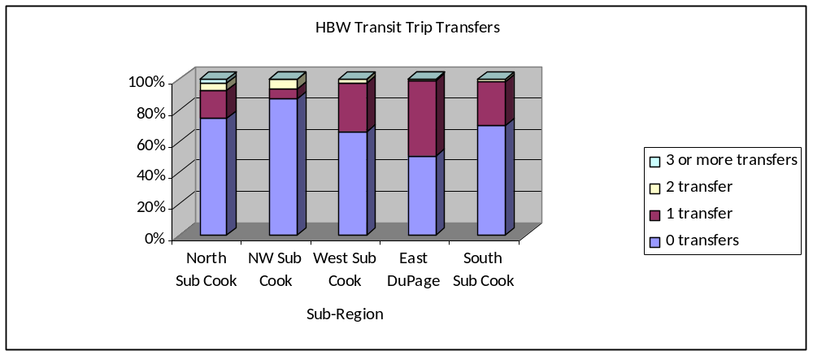

Table 9 Transfers for HBW transit trips by sub-region
 |  | Number of Transfers
 |  | 0 transfers | 1 transfer | 2 transfer | 3 or more transfers | Total
North Sub Cook | % | 74.8% | 17.7% | 4.9% | 2.5% | 100.0%
NW Sub Cook | % | 87.1% | 6.5% | 6.4% | 0.0% | 100.0%
West Sub Cook | % | 66.4% | 31.2% | 2.0% | 0.4% | 100.0%
East DuPage | % | 50.6% | 48.3% | 1.1% | 0.0% | 100.0%
South Sub Cook | % | 70.1% | 28.5% | 1.1% | 0.2% | 100.0%
Study Region | % | 69.9% | 26.0% | 3.1% | 0.9% | 100.0%

Transit Trip Characteristics
Table 10 displays trip related data for HBW trips that originate in each of the respective study regions. Average trip distances are highest for Northwest Suburban Cook County, and are lowest for North Suburban Cook County. Due to the importance of the traditional commuter trip to the CBD for transit trips in the study region, trip distance (and travel times) is highly affected by the proximity of the sub-region to the Chicago CBD. These statistics are also a result of the availability of different modes and service boards in each of the sub-regions. The sub-regions with the highest level of use of CTA bus and CTA rail, north and West Suburban Cook County, have the lowest average trip speed.

Table 10 Trip data for HBW transit trips by sub-region
 |  | Distance (miles) | Travel Time (minutes) | speed (mi/hr) | Number of buses or trains used
North Sub Cook | Mean | 12.7 | 52.9 | 14.4 | 1.4
NW Sub Cook | Mean | 32.6 | 113.2 | 17.3 | 1.2
West Sub Cook | Mean | 16 | 67.6 | 14.2 | 1.4
East DuPage | Mean | 25.6 | 83.8 | 18.3 | 1.5
South Sub Cook | Mean | 19.05 | 66.6 | 17.2 | 1.3
Study Region | Mean | 18.5 | 69.8 | 15.9 | 1.4

Figure 6 displays the percentage of HBW transit trip transfers for each sub-region along with their respective average speed for HBW trips. There does not appear to be a relationship between transfers and average trip speed in the study region. For example, East DuPage County has the highest average speed for HBW transit trips, but it also has the highest percent of trips that require a transfer. Travel time savings are important in attracting new ridership as shown by relatively strong agreement ratings from the RTA Behavioral and Attitudinal Survey for the statement “regardless of cost, I choose the fastest way to travel.”

Figure 6 HBW transit trip transfers and travel speed by sub-region
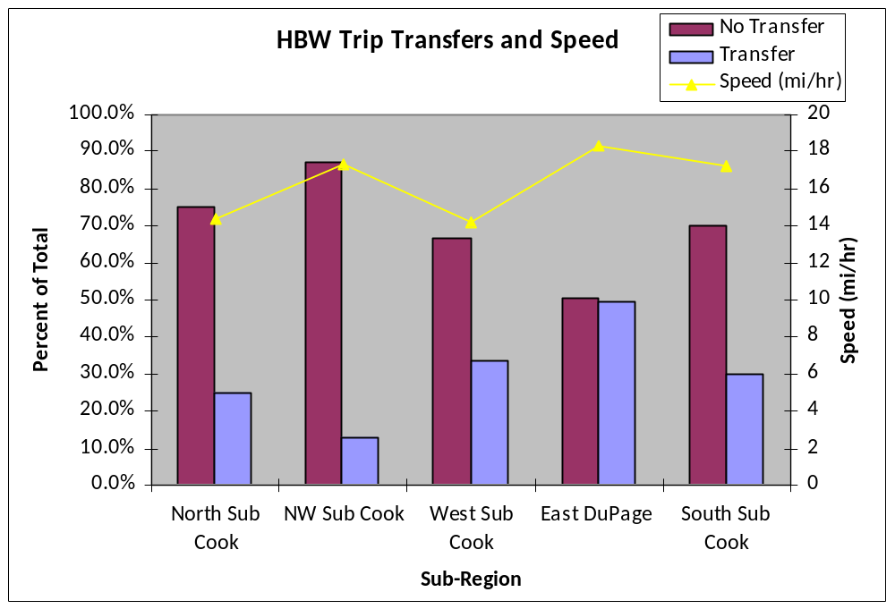

- Findings & Conclusions from HBW Regional & District Trip Interchanges

For each of the sub-regions, a detailed analysis of HBW trip productions and attractions was conducted focusing on trip interchanges between specific geographies, including between the sub-region and the CBD, between the sub-region and Chicago, between sub-regions and between districts. Adjacent counties were also included in the regional trip interchange analysis due to proximity to the respective sub-regions.

Building off of the recommendations from the RTA Travel Market Analysis, the focus of the suburban Cook County analysis is non-traditional trips and to highlight sizable HBW trip interchanges where transit is currently serving a minimal percent of the market. This is an indicator that transit has a “foothold”, with established infrastructure or service, but has room to grow. Increasing transit use for these markets may be achievable with little investment, by utilizing and restructuring existing transit resources and infrastructure.

A prevailing pattern that became apparent when conducting the regional trip interchange analysis for each of the sub-regions was that there was often times a directional modal mismatch between the production and attraction numbers for HBW trips by all modes and for HBW trips by transit. More specifically, a sub-region may export more trips than it imports for trips by all modes, but the opposite would be true for trips made by transit. Directional modal mismatches present opportunities to capture potential demand for transit and merit further analysis of the transit services that link the trip productions and attractions.

Provided here are primary findings and areas identified for additional examination for each sub-region. It is important to note that county-level 2000 Census Transportation Planning Package was utilized to develop the trip weights for the surveyed trips. Therefore, trip interchanges at the RTA district level should be examined with caution.

North Suburban Cook County
Directional Modal Mismatches:
- North Suburban Cook County and Lake County: North Suburban Cook County attracts more trips than it produces to Lake County when examining trips by all modes, however the opposite is true when solely looking at transit trips. Further examination of the alignment of transit services that connect the two regions could be pursued to potentially capture unmet demand.

- North Suburban Cook County and Northwest Suburban Cook County: North Suburban Cook County attracts more trips by all modes than it produces to Northwest Suburban Cook County. However, the data shows that the only transit trip interchanges between the two sub-regions are for trips produced in North Suburban Cook County and attracted to Northwest Suburban Cook County.

Existing Markets to Grow:
- HBW trip interchanges produced in district 12 (Wilmette, Winnetka, Glenview, Northbrook) and attracted to district 10 (Palatine, Arlington Heights, Mt. Prospect, Wheeling) have a transit market share of 6.4 percent. Improving the transit connections between the two districts could potentially increase the existing transit market. Currently, only Pace Shuttle Bug services link the two districts. Pace Shuttle Bug s only provide rush hour service for commuters to employment sites in the Lake-Cook employment center.

- Although they are adjacent sub-regions, there are very few HBW transit trip interchanges between North Suburban Cook County and West Suburban Cook County. North Suburban Cook County only imports a small amount of transit trips (4.4 percent transit market share) and exports an insignificant amount of trips to West Suburban Cook County. It is likely that O’Hare airport in district 15 creates a physical barrier for transit services that would connect the two sub-regions.

- Trip interchanges for trips produced in district 11 (Des Plaines, Park Ridge, Niles, Morton Grove) and attracted to district 16 (Chicago: Jefferson Park, Portage Park) could be further analyzed in order to increase the transit share. There is a high volume of trips attracted to district 16, with a transit market share of 3.5 percent. These two districts are linked by the UP-NW Metra Line and four Pace Bus routes: 209 Busse Highway, 270 Milwaukee Ave, 423 Linden CTA, and 411 Niles Local Service.

- There are a significant amount of trips produced in district 13 (Evanston, Lincolnwood, Skokie) and attracted to district 12, with a current transit market share of 6.1 percent. In addition to being linked by the UP-N line, the two districts are linked by three Pace Bus routes: 213 Green Bay Road, 422 Linden CTA, and 626 Skokie Valley Limited.

Northwest Suburban Cook County
Directional Modal Mismatches:
- Northwest Suburban Cook County and West Suburban Cook County: West Suburban Cook County produces transit trips that are attracted to Northwest Suburban Cook County for a total transit share of 1.4 percent. However, Northwest Suburban Cook County produces an insignificant amount of transit trips attracted to West Suburban Cook County.

Existing Markets with Room to Grow:
- Trip magnitudes for trips by all modes are relatively high for interchanges between Northwest Suburban Cook County and Lake County. However, the transit shares are low for trip productions and attractions, at .5 percent and .2 percent respectively.

- Although trip volumes for trips produced in district 9 (South Barrington, Barrington Hills, Inverness, Hoffman Estates) and attracted to district 5 (Lake County: Libertyville, Vernon Hills) are relatively low, transit has a 21 percent market share. This market share is almost equivalent to that of trips produced in district 9 and attracted to the CBD. Currently, the two districts are linked by Pace Bus route 557 The Hot Line – Barrington Road Corridor. This is a rush hour only community service route that runs southbound in the morning and northbound in the evening.

West Suburban Cook County
Directional Modal Mismatches
- West Suburban Cook County and Will County: West Suburban Cook County produces a relatively high magnitude of trips that are attracted to Will County. However, Will County produces an insignificant amount of transit trips attracted to West Suburban Cook County.

Existing Markets to Grow:
- The reverse commute market between West Suburban Cook County and the City of Chicago (outside CBD) has a higher transit share (9.5 percent) than that of the traditional commute market (3.5 percent). Further analysis could be pursued to potentially grow this market with considerations made to capacity, currently served markets, etc.

- There is a high volume of HBW trips that are produced in district 20 (Oak Park, Maywood, River Forest, Berkeley, Northlake) and attracted to district 21 (Chicago: Austin, Garfield Park, Humboldt Park, United Center, Medical Center). The high volume of trips produced in district 20 and attracted to district 21 has a total transit market share of 2.3 percent. This trip interchange is a traditional HBW trip and the two districts are linked by Metra’s UP-W line, CTA Blue Line, CTA Green Line and numerous CTA and Pace bus routes.

- The reverse commute market between West Suburban Cook County and the City of Chicago has a transit share of 9.5 percent. West Suburban Cook has access to high frequency transit service having access via two CTA rail lines, in addition to being served by three Metra lines. Further analysis could be pursued to potentially grow this market with considerations made to capacity, currently served markets, etc.

Observations:
- HBW transit trip productions account for 71 percent of transit trip productions for all purposes from West Suburban Cook County. The strong dominance of HBW trips could be considered when aiming to grow transit markets in the sub-region.

- Transit is not well utilized for trip interchanges between West Suburban Cook County and South Suburban Cook County. This is likely due to low volumes of trips form South Suburban Cook County in general, and poor transit integration between major generators in the two regions.

- West Suburban Cook County is one of only two sub-regions (the other being South Suburban Cook County) in the analysis to have a relatively high amount of internal transit trips.

- There are a total of 1,486 HBW trips produced in district 31 (Oak Lawn, Palos Park, Orland Park, Lemont) and attracted to district 15 (O’Hare International Airport, Rosemont). Transit captures the majority of these trips at 72.8%. Pace Bus route 330 Manheim – LaGrange Road links the two districts and has an average daily ridership of 1,084 (November 2010).

East DuPage County
Existing Markets to Grow:
- East DuPage County does not attract a significant amount of transit trips from Will County, but does attract a significant amount of trips when examining trips by all modes.

- Despite there being a high volume of trip interchanges between East DuPage County & suburban Cook County and between East DuPage County and west DuPage County, there are very few transit trip interchanges (regardless of trip purpose) between these sub-regions.

Observations:
- East DuPage attracts more trips than it produces to the city of Chicago.

- Transit does a good job at capturing the reverse commute market for trip interchanges between East DuPage County and the CBD.

- Almost all transit trips produced in eastern DuPage County and attracted to Will County are HBW trips. The same is true for trips attracted to eastern DuPage County from Lake County.

- District 40 (Elmhurst, Villa Park, Lombard) produces a significant amount of trips that are attracted to district 43 (Plainfield, Bolingbrook).
South Suburban Cook County

Existing Markets To Grow:
- There is a significant amount of trip interchanges between South Suburban Cook County and Will County, as well as, South Suburban Cook County and West Suburban Cook County. However, there are no significant transit trip interchanges between the two regions. Transit linkages between South Suburban Cook County and Will County could be further examined to potentially build a transit market.

Observations:
- South Suburban Cook County is the only sub-region, besides West Suburban Cook County, that produces a relatively significant amount of internal transit trips. Further, HBW trips produced and attracted in district 35 (Harvey, Dolton, South Holland) have a high transit share. Of the HBW transit trips produced and attracted within district 35, 13 percent are completed utilizing transit. Throughout the suburban Cook County travel market analysis, internal HBW trips consistently ranked as the highest in trip volume, yet demonstrated low transit market shares. Understanding what makes short internal trips in district 35 successful via transit could potentially serve as an example for how to successfully increase the transit market share. Appendix B further examines the internal HBW trips made in district 35.

- South Suburban Cook County interchanges HBW transit trips with only two other regions: city of Chicago and the CBD. The magnitude and directionality of trips is similar when comparing trips by all modes and those completed by transit.

Appendix A. RTA District Map & Sub-Region Map
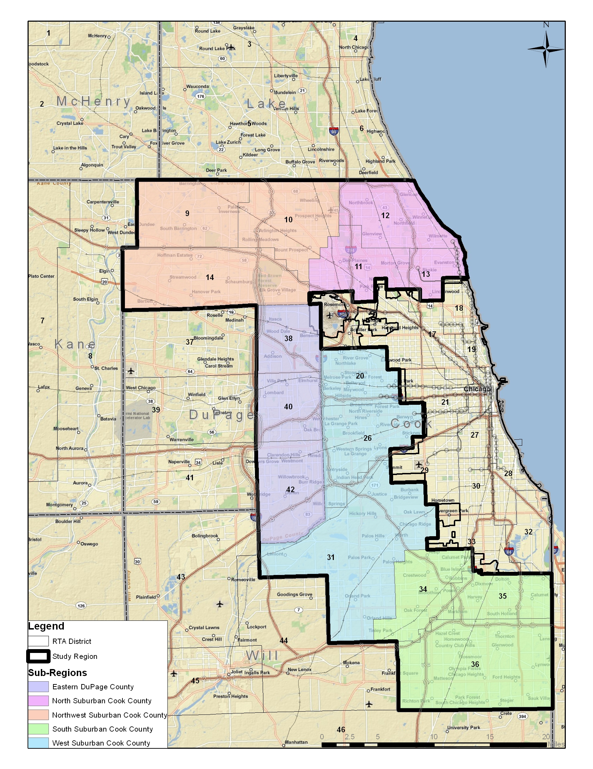

Appendix B. Internal HBW Trips in District 35

One hypothesis for the high transit use for internal trips is income. District 35 contains many low income municipalities and as shown in Table 11, contains the highest percentage of households in the lowest two income cohorts of the three South Suburban Cook County districts. As discussed earlier, income use in the region is highest among the lowest and highest income cohorts, however, this pattern is not the case when examining the just the study region of the analysis.

Table 11 Household incomes in south suburban Cook County
 |  | Household Income |  |  |  |  |  |  |  | Total
 |  | Less than $20,000 | $20,000 - $34,999 | $35,000 - $49,999 | $50,000 - $59,999 | $60,000 - $74,999 | $75,000 - $99,999 | More than $100,000 | Refused | Total
34 | % | 5.60% | 5.30% | 21.70% | 6.10% | 8.90% | 33.40% | 13.40% | 5.60% | 100.00%
35 | % | 24.40% | 43.80% | 13.70% | 3.60% | 7.10% | 4.20% | 2.40% | 0.80% | 100.00%
36 | % | 14.60% | 18.70% | 11.10% | 7.60% | 7.20% | 12.60% | 24.70% | 3.60% | 100.00%
Total | % | 13.50% | 19.30% | 15.20% | 6.30% | 7.80% | 17.90% | 16.30% | 3.70% | 100.00%

In addition, district 35 contains the highest number of households with zero and one vehicle households of the three districts in South Suburban Cook County. However, district 35 also has the largest share of households with zero and one worker households.

While it is difficult to quantify level of service for each of the districts, district 35 has access to CTA Bus, Pace Bus, and Metra Rail. This fact alone will increase transit use; however, it will be helpful to gain a better understanding as to what transit modes are being most utilized.

